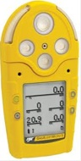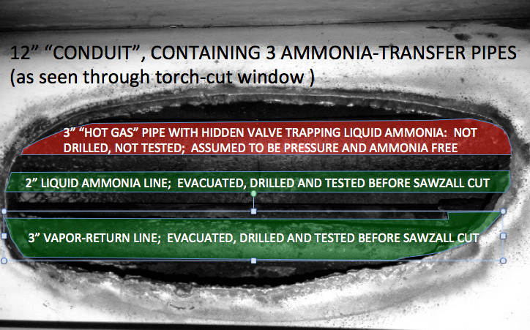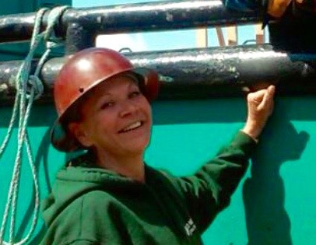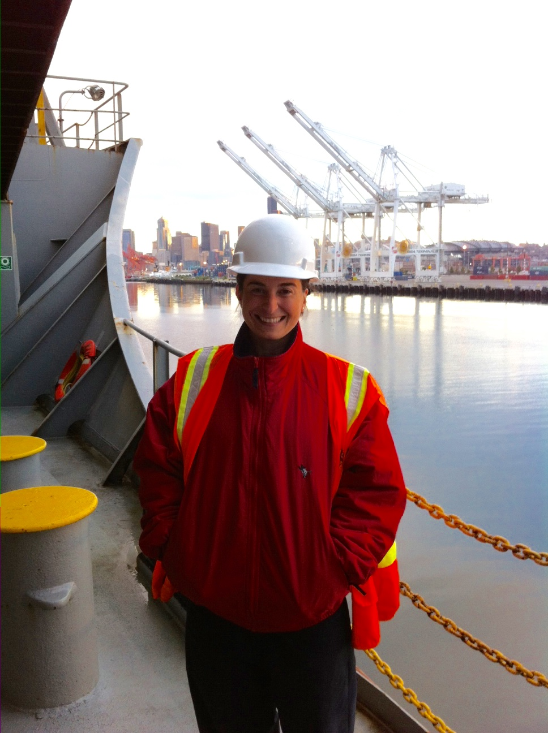

**Next class: October 15-16**  
10-hour training on 29 CFR 1915 or 1910 provides methods on recognition, avoidance, abatement, and prevention of safety and health hazards in workplaces specific to the maritime or general industries.

#### OSHA 10 Maritime

#### & General Industry

To begin repairs the engineer, reading the existing prints, opened the system's valves. Next, he had a contractor pump all liquid from the main receiver. Then the crew put the system under 30" of vacuum for 3 days to exhaust any ammonia trapped in scale or compressor oil.

Then, under the Chief’s direction, the crew drilled test holes both in the conduit and on accessible sections of lines outside the conduit. Every test showed only background ammonia at 0 psig.

At last the engineer gave permission to torch-cut a window (pictured) in the conduit to access the pipes within. Then, reaching through the window with a sawzall, workers cut the first 2 pipes free without incident.

But when he cut into the third (hot gas) pipe a worker was met by a blast of liquid ammonia. Of course, the space was cleared and vented to control the ammonia release. (Fortunately, after hospitalization the exposed worker has recovered completely.)

(Continued on the next page)

Not all conduit pipes are electrical. Heavy-duty pipes are used in some refrigeration systems to protect and enclose smaller pipes in traffic areas or machinery rooms.

So it was that a fish processor crew had to cut into a 12" "conduit" for emergency repair to a wasted section of "hot gas" ammonia piping within. (Also in the conduit were a 3" ammonia vapor return line and a 2" liquid ammonia pipe.)

**3-Day Initial**

Oct 7-9

Nov 4-6

Nov 18-20 (Shoreline)

**1-Day Updates**

Oct 8

Oct 21

Nov 5

Nov 18

# **Liquid Ammonia?? Careful!**

#### Shipyard Competent Person

### Training

**SCP Tribune ©**

**Rachel McKay, Owner of  
Sound Marine & Industrial Services, Inc.**

An article in the September 6th ***Seattle Times*** focused on "**Women in Industry**." The message? “**Women have to be physically and mentally strong in the trades.**” Featured as pioneering craftswomen were drivers of trucks and heavy equipment; a line-person and an industrial electrician; a meat cutter and laborer; a pile-driver and a firefighter.

Strangely invisible to the authors were all those hundreds of women who have worked for decades in ship repair and maritime trades as welders, fitters, pipefitters, tank cleaners and laborers, superintendents and project managers. All the licensed female mates, engineers and captains, the port engineers and ship superintendents were similarly below the Times’ radar.

With its tugs, barges, fishing fleet, cruise lines, shipbuilding and repair, electronics repair, hydraulics and refrigeration, lawyers, architects, insurance, firefighters, line handlers, rail and warehousing, truck drivers and government agencies (from the Coast Guard to the Department of Agriculture) the sector we all work in pays living wages to thousands of women among   
 some 150,000 Washington Maritime workers.

But when it comes to political and media recognition our industry seems invisible. As the kids say, “Go Figure??!”

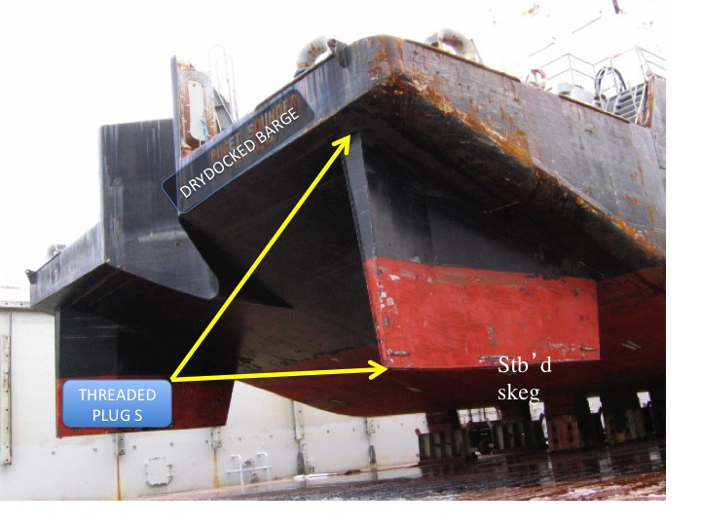

**Nicole Lamanna Linn, Licensed Second A/E and Port Engineer for Matson.**

# **Under Their Radar**

What Happened? 3 things: First; an isolating valve on the hot gas line, obscured by foam insulation, remained closed, trapping liquid ammonia. Second; out-of-date prints didn't show the valve or its location. And third; after getting no ammonia or pressure from the first 5 drilled holes, the worker assumed the system was truly "down" and decided not to bother testing the last pipe which had not been made safe.

In this ammonia system repair, as with most serious misfortunes, several unlikely happenings very nearly combined for a disaster. Though these workmen worked hard and knew their craft, they came up a little short in the safety side of things. That bothersome safety culture, with its picky rules and safety details, is meant to deal with the unforeseeable.

# **Liquid Ammonia, cont.**

**Question:** HowdoesSoundTestingguaranteetheprocessforselectingthewinningquizansweristrulyrandom??

**Answer:** Nothing is more random than the efforts of young Mr. Adam Liu, as he extracts the fortunate entry from among the collected wisdom of our readers.

Last month’s ***Tribune*** noted a disturbing fuel terminal practice called “Pinning the Legs” (of a floating roof.) Our tank-cleaning friends have been asked to work in fatal levels of gasoline vapor, and only supplied-air gear would keep them alive. (Of course, we ship-repair people religiously avoid any hint of such danger.)

As promised, here is an update on the progress of this project: "As of Sept. 30, the leg pinning project has been delayed. IDLH conditions still exist inside Tank# 6. Right now the tank atmosphere is above the UEL. We plan on venting the space until acceptable entry conditions are met."

Serious ventilation will be required. But, as we say in the shipyards, “Air is cheap!”

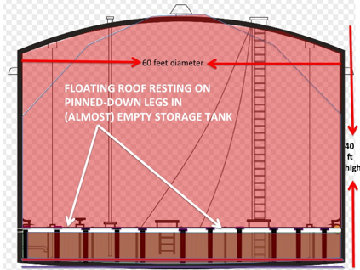

# **Pinning the Legs. Part II**

# **Ask a Chemist**

Congrats to **Glenn Dudley** of **Gambol Marine:** Winner of September’s quiz and a $25 gift card!  
 **September’s Question:  
Q:** A vessel's after below decks stowage got its name from "Quarantine Ships" with sick immigrant passengers imprisoned aft. What's the name, and what's the connection?  
**A:** “The most fearsome patients on the quarantine ship were the lepers, stowed below decks aft in what was known as the "Lazarette." The term, a biblical reference to Lazarus, still today means the after, below-decks stowage on fishing, towboats and pleasure-craft.”

**October’s Question:** Many licensed crewmembers have been to the Fire-Fighting school in North Bend. Their fire-fighting gear, often made of heavy canvas, has the same name as that black, residual fuel engineers use to fire boilers and slow speed diesels. What is that term?   
**Submit your answers** to [newsletter@soundtestinginc.com](mailto:newsletter@soundtestinginc.com) before October 25, 2015. All correct answers will be entered into a random drawing and one person will win a $25 gift card! One entry per person, please.

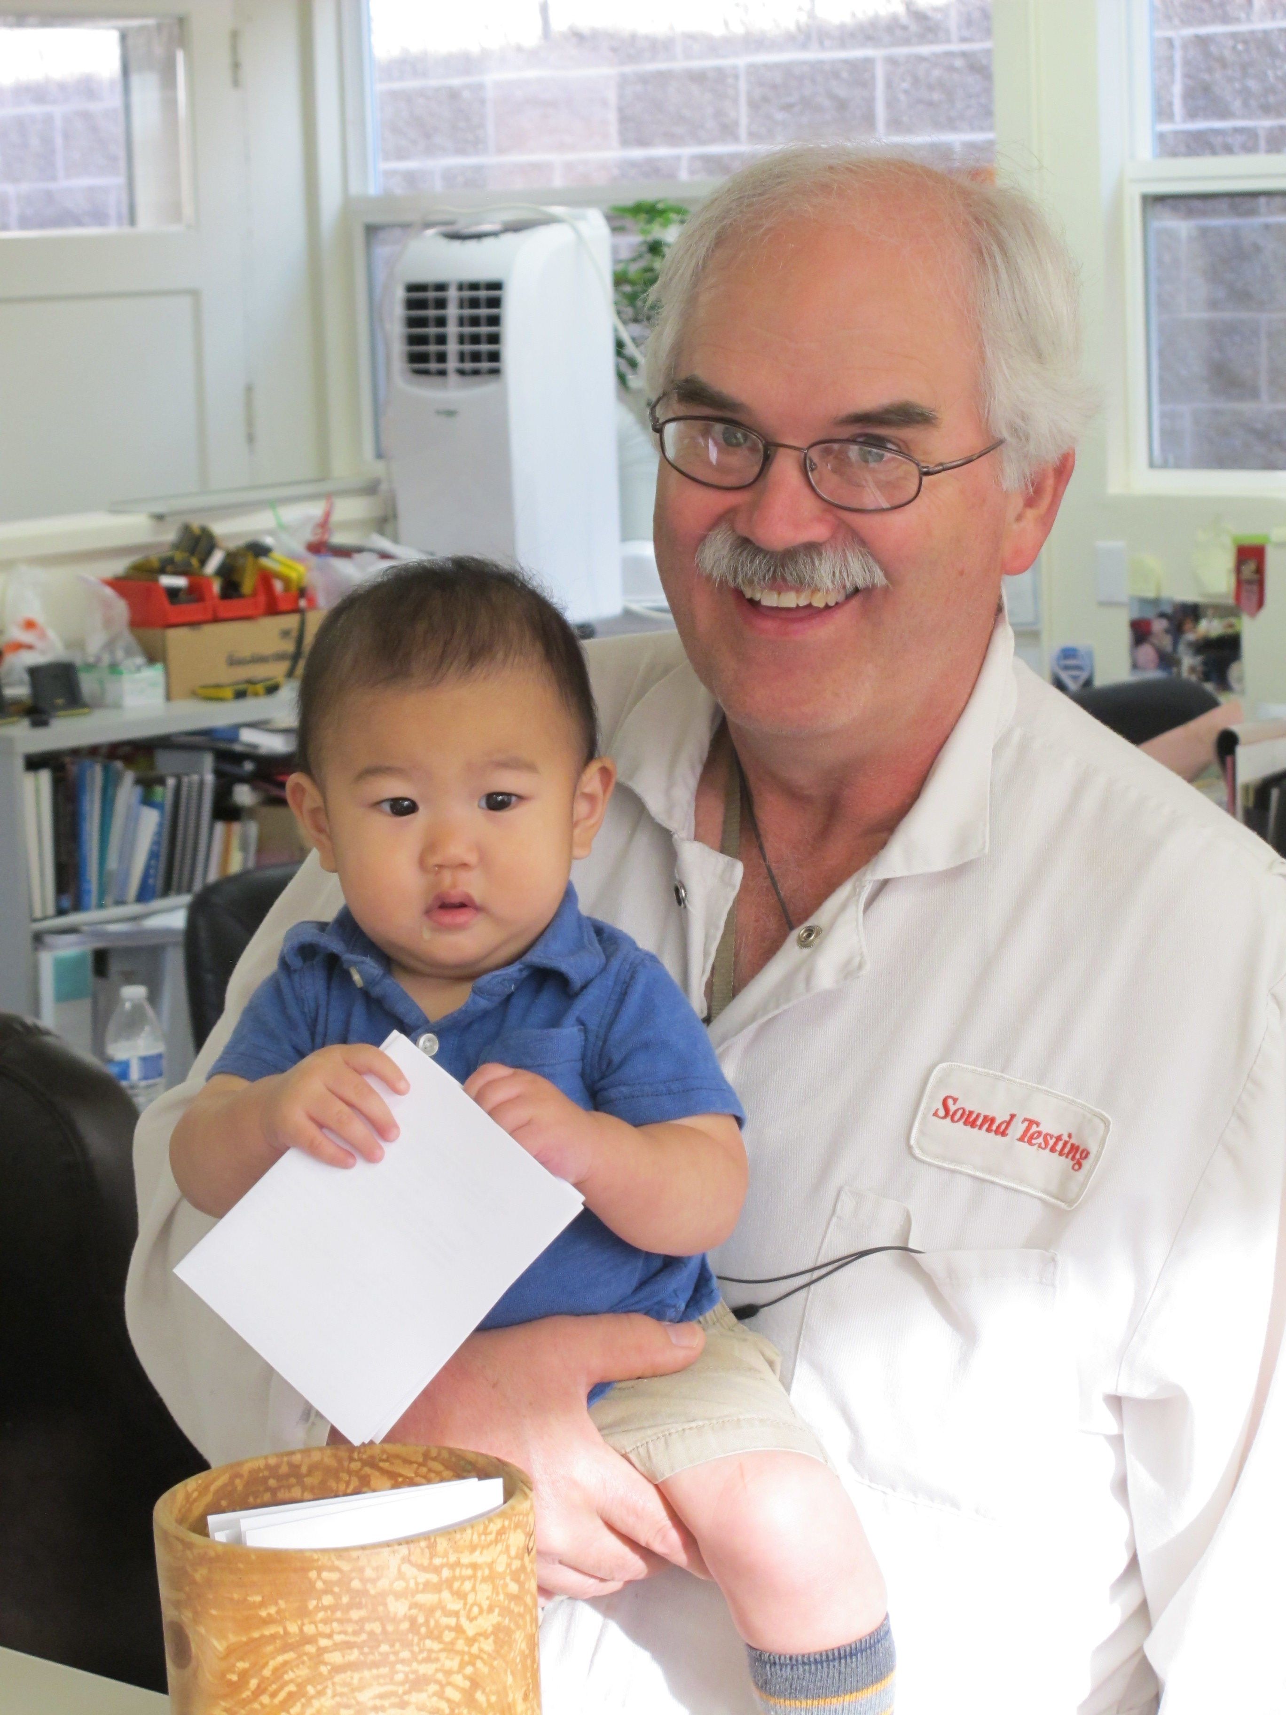

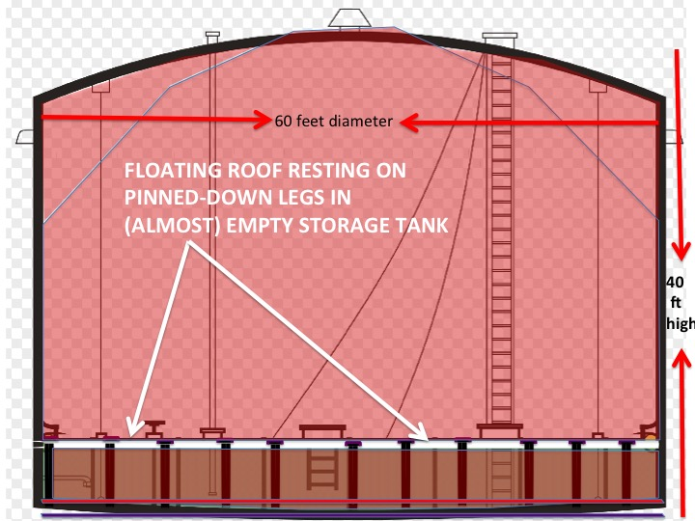

Sound Testing, Inc. PRSRT STD

PO Box 16204 U.S. POSTAGE

Seattle, WA 98116 PAID

SEATTLE, WA

Return Service Requested PERMIT NO. 1865