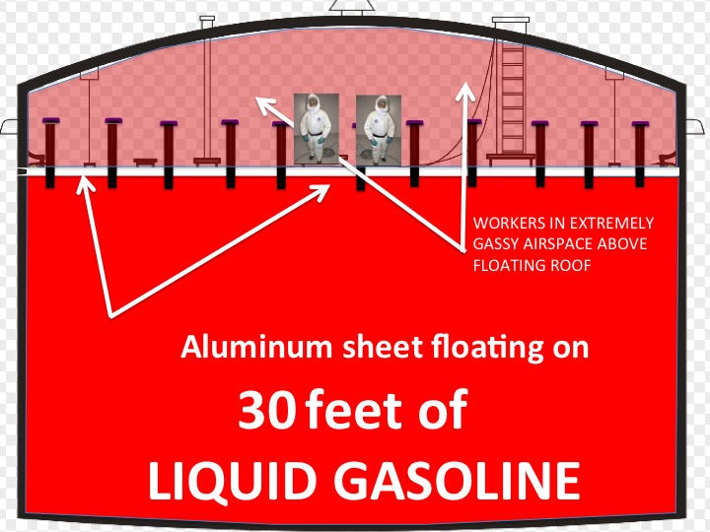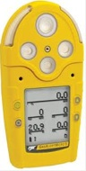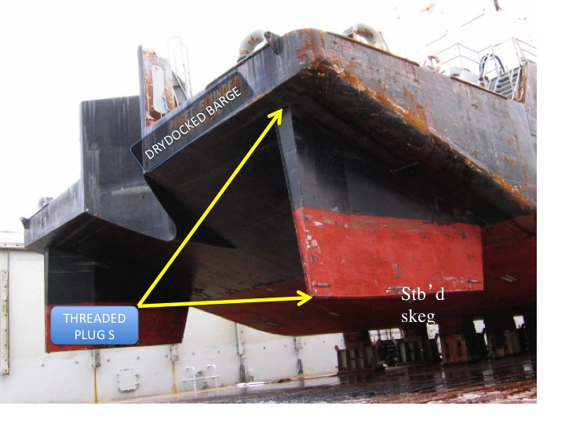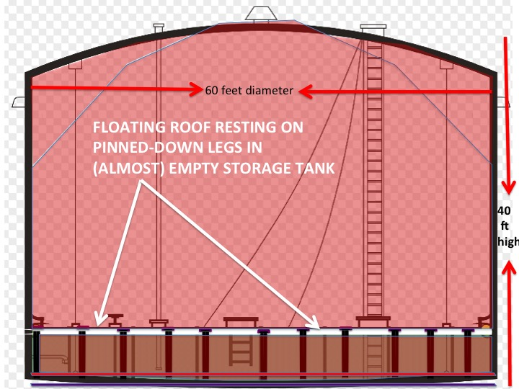

sheet aluminum. They float on the tank’s product to cut down evaporation loss.

But for the tank to be serviced after its contents have been pumped out, the floating roof can’t just flop on the floor, but must stand on some “legs”, much as a pickup camper stands on supports when it’s removed from the pickup bed.

To engage the roof’s many “legs” before the tank is pumped out, someone has to enter through the upper roof, climb down the ladder, and walk on the sheets floating on 30 feet of gasoline so they can “pin” (Continued on the next page) those legs. It takes about an hour.

A Tank Cleaner, as we have often noted here, has standing because he enters a Confined Space in the worst of conditions: before it’s been cleaned. That’s why tank cleaners have their own special section in OSHA’s Maritime Standard (CFR 1915) “Cleaning and Other Cold Work.”

And that section focuses on the Tank Cleaners’ absolute requirement to avoid working in anything like an IDLH Atmosphere. (That acronym stands for “IMMEDIATELY DANGEROUS TO LIFE”.) Practically speaking, IDLH air is so contaminated that it will kill an unprotected worker before he can get out or be rescued. Again, IDLH has no place in ship repair. We depend reluctantly on respirators for comfort; we do NOT depend on them for our lives.

But just now somebody got word that, because they are the only highly-trained, well-equipped folks in the neighborhood, some Alaskan tank cleaners have been asked to step outside their Maritime training and do a very dangerous job:

They must “pin the legs” of the “floating roof” of a fuel terminal’s gasoline tank.

Shore tanks with extremely gassy cargoes, such as alcohol or gasoline, tend to have such roofs, commonly made of

10-hour training on 29 CFR 1915 or 1910 provides methods on recognition, avoidance, abatement, and prevention of safety and health hazards in workplaces specific to the maritime or general industries.  
Please call our office (932-0206) for the next class date.

# **Pinning the Legs**

#### OSHA 10 Maritime

#### & General Industry

**3-Day Initial**

Sep 9-11

Oct 7-9

**1-Day Updates**

Sep 10

Sep 23

Oct 8

Oct 21

#### Shipyard Competent Person

### Training

**SCP Tribune ©**

# **Pegging the Meter**

August's *Tribune* observed that meter readings don't tell us much about whether or not a material is a fire danger. But if anyone thought we were declaring meter readings to be trivial or optional or unimportant for ship repair safety, think again. Meter readings give us essential warnings about unstable workplace safety; they prevent us from killing ourselves on initial entry to confined spaces; and, importantly, they're absolutely the only way you can detect many explosive dangers.

In late August, repairs to the leaky Stb’d skeg of an old barge made believers of everyone on the drydock. Skegs, of course, are hollow structures and so must be meter-checked by the Competent Person. When the lower threaded plug was loosened, water dripping out meant “Go Ahead!” to the welder and his helper. But the SCP, dealing in the World of Certainty, declared “Hold on, we need the upper plug out too.”

Why the upper plug too? The Competent Person was concerned. What might be floating on the water? Was the air above the water gassy? (Continued on the next page.)



But in the Alaska Job that upper void, between the floating and permanent roofs, was absolutely saturated with gasoline vapor. Five or six breaths of that air would kill any unprotected worker. Shouldn’t they ventilate any IDLH space?

Two reasons why they can’t:

First, the volume, unlike a vessel’s fuel tank, is just too big and the gasoline evaporates too quickly. It is millions, not thousands, of gallons.

Second, terminal managers rely on that gasoline vapor being too thick to explode. It gives a measure of safety (not very much…). And ventilating would mix air with the thick gasoline vapor, making it even more explosive. (In the shore tank world, owners often want gasoline vapor at least 70 or 80 TIMES more concentrated than us ship repair chemists would allow on such a job!)

So our Alaskan friends will stretch both their training and their equipment to deal safely in that shoreside world. They (and their tank watch) will use full-face supplied air respirators with emergency escape cylinders; they will spend days of training in the details of CFR 29 1910.146. We’ll report next month on their success in this project outside our comfort zone.

# **Pinning the Legs, Cont.**



**Question:**The “photoionization” (PID) function of our meter stopped working, but the LEL function is fine. Since we’re interested in testing levels of paint solvent vapor, we wonder; why not use the Lower Explosion Level measurement? Why do we need the PID?

**Answer:** Measuring paint solvent vapor with the combustible gas cell is a little like using a 25-foot tape to measure the width of a hair: Like the 25-foot tape, the LEL function is just too crude for the job. If you want to measure airborne paint solvent you should invest in the photoionization function. It measures not in the percentage range, but in parts per million. (Recall: 1% = 10,000 ppm.)

The PID is a little more complex to use because numbers for individual chemicals must be multiplied by “correction factors” supplied by the meter manufacturer.



Testing the skeg void from the top told the SCP 3 things: First, the bottom opening was actually plugged with scale; Second, the skeg was 1/4 full of water, but no preservative; And third, the air above the water instantly "pegged" the combustible gas cell! That skeg was absolutely explosive! (Later the Chemist's meter behaved the same; Instant Overload.)

2-minutes of compressed air and the gas was gone. (No, we never found its origin. Perhaps methane from bacteria??) But, isn't it better to find the gas with a meter instead of being on the evening news?? Good work, Shipyard Competent Persons!

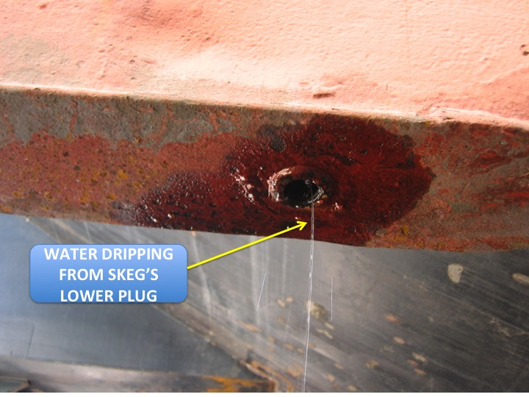

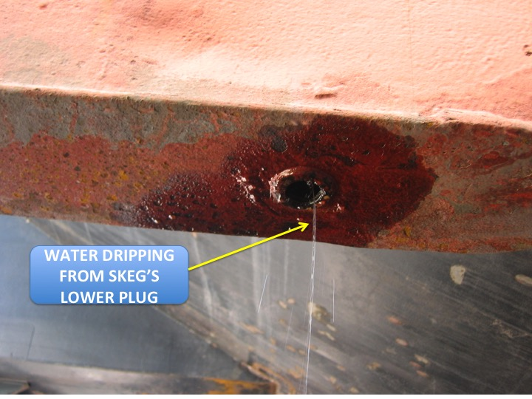

# **Pegging the Meter, Cont.**

# **Ask a Chemist**

Congrats to **Louis D’Andrea** from **Crowley** for winning last month's quiz and a $25 gift card!  
(Honorable Mentions too numerous to mention!) **Last Month's Quiz:  
Q:** The superintendent instructs the riggers, "...range those shots for blast and coat, right to the bitter end!" What in the world is the superintendent referring to?  
**A:** The superintendent is referring to the anchor chain. The bitter end is connected to the vessel’s chain locker.  
**This Month's Question:** Around 1900 the Federal Government maintained a Puget Sound “Quarantine Station” near Port Townsend at Diamond Point. A derelict dock remains. A vessel's after below decks stowage got its name from those "Quarantine Ships" with sick immigrant passengers imprisoned aft. What's the name, and what's the connection? **Submit your answers** to [newsletter@soundtestinginc.com](mailto:newsletter@soundtestinginc.com) before September 25, 2015. All correct answers will be entered into a random drawing and one person will win a $25 gift card! One entry per person, please.

Sound Testing, Inc. PRSRT STD

PO Box 16204 U.S. POSTAGE

Seattle, WA 98116 PAID

SEATTLE, WA

Return Service Requested PERMIT NO. 1865